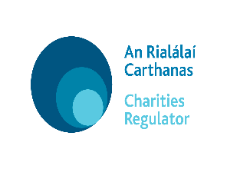
Charities Regulatory Authority

Template Statement of Willingness to Act and section 55 Declaration

[INSERT NAME OF CHARITY]

REGISTERED CHARITY NUMBER _______________

I,____________________, [insert name and office held by the proposed trustee], of _________________________ [insert habitual address], confirm that that I am willing to act as Trustee in respect of the property known as ________________________. I further say and certify that I am not a person disqualified from acting as trustee of a charitable organisation by virtue of section 55 of the Charities Act 2009 and specifically declare as follows:

• I am not an undischarged bankrupt
• I have not made a composition or arrangement with any creditors
• I have never been convicted on indictment of an offence
• I have never been sentenced to a term of imprisonment by a court of a competent jurisdiction
• I am not the subject of an order under Part 4 of the Companies Act 2014
• I am not prohibited, removed or suspended from being a trustee of a scheme under the Pensions Acts
• I have not been removed from the position of charity trustee of a charitable organisation by an order of the High Court under section 74 of the Charities Act 2009.
• If a company, it is not in the process of being wound up.

I understand that it is an offence under section 39(15) of the Charities Act 2009 knowingly or recklessly provide false or misleading information.

Dated this ______ day of __________________ 20____.

Signed: _______________________________________

